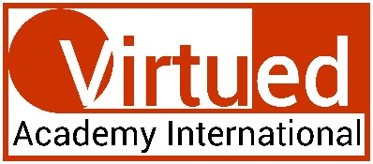
This certificate is granted to

Ebony Carter
in recognition of completing the Virtued Academy International’s

Certification in Reiki
(Level I, II, and III/ Master/ Teacher)
 | 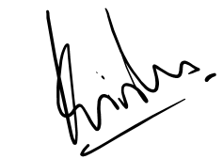  PROF KRISHNA N SHARMA  Course Coordinator |  | Date: 29th day of febuary 2024
 | Note: This certificate is valid only with Udemy's certificate of completion. In absence of Udemy's certificate, this certification shall be considered null and void.

