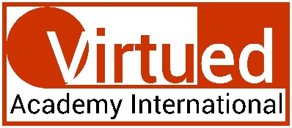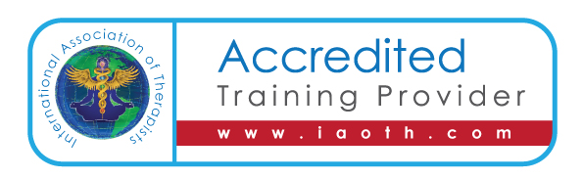
This certificate is granted to

Amanda Corlew
in recognition of completing the Virtue Academy International’s

Certification in Spiritual Healing
 | 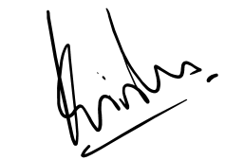  PROF KRISHNA N SHARMA  Course Coordinator |  | Aug 21st 2021
 | Note: This certificate is valid only with Udemy's certificate of completion. In absence of Udemy's certificate, this certification shall be considered null and void.

